OHA Board Meeting January 6, 2015
Minutes of Meeting
-- REMINDERS --
Herd moves: horses not moving with group must be out one hour (or more) before the move.

Try small block salt in the pasture, placing it far away from water (to reduce loose salt on pasture grass, and to reduce herd hanging out at water/salt area).

Please take dirty hay from Pavilion home to put in your green cans & return empty bags.

Please sign up for any tasks you are interested in on the OHA Tasks Volunteers 2015-2016 Spreadsheet:
https://docs.google.com/spreadsheets/d/1MPWI6IYEy5P-gRWHnH5apBy0_ebuvx0NCbNmBzMrbAc/edit?usp=sharing

Location of Meeting: Allison Bloodworth’s home
Board members in attendance: Allison B., Eddie, Heather, Kirsten, Linda

The meeting commenced at 7pm.

Approvals
- Approval of minutes of last board meeting in November.
- Agenda for this meeting
  - Added Discussion of Capital Improvements (covered in EBMUD report)
  - Removed Red Barn Repairs since this will be tackled in the spring
Treasurer’s Report

There was no report as Alison Martin was unable to attend this meeting.

EBMUD Report

Four capital improvement projects were approved by EBMUD for 2015-2016:

- Rotational Grazing Program: Tier Three
- Mowing for weed control
- Hay Station for a trial of alternate method of hay protection
- Valve for Upper Sullivan Trough
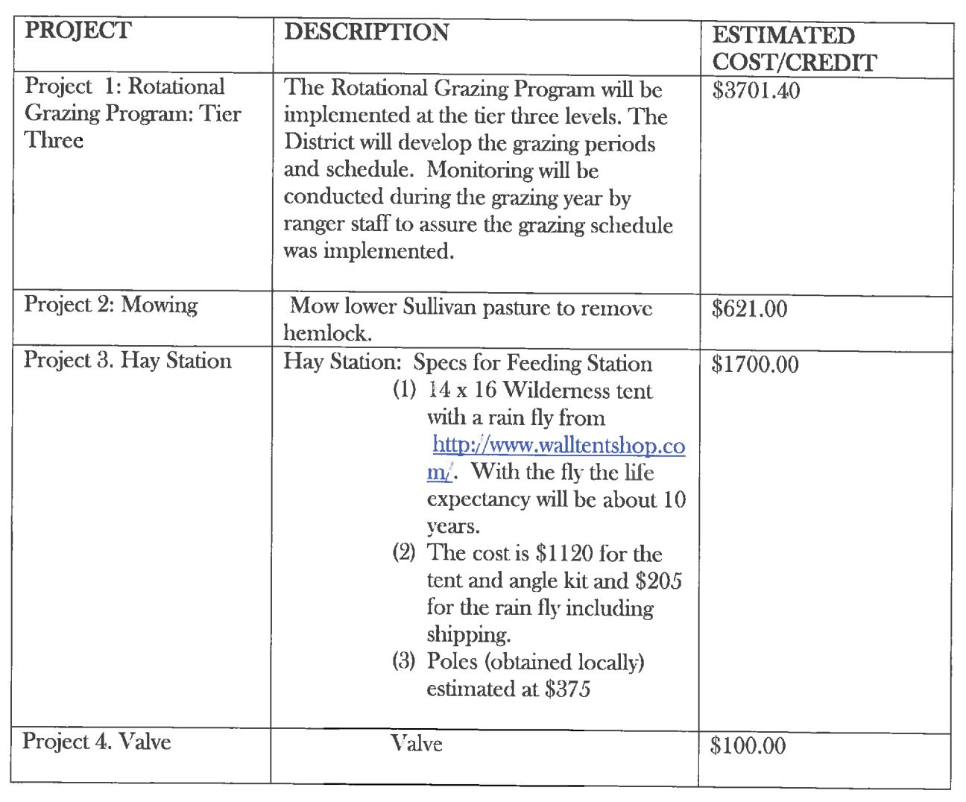

For more information, the entire 2015-2016 AGP is available on the OHA website at the top of the “EBMUD Documents” page: http://www.orindahorsemen.org/EBMUD+Documents

The board will reach out to members who have been interested in projects like these in the past to find project coordinators. Please contact the board if you are interested in volunteering for one or more of these projects.

Heather will follow-up with EBMUD about the following items:

- Fixing the ring pasture fence
- The gap in the fence at Tilden on the Seaview Trail near the highest point
- Bringing asphalt or gravel to improve vehicle access to the red barn
- Determine where the road through Upper Sullivan gets wet, to see if they can improve drainage

Membership Committee Report

Due to the condition of the pasture, the board decided to hold off on interviewing for the 1 currently empty horse space. We will revisit this question at the next meeting.
The OHA Procedures for the Membership Committee currently state:

iii) When a space becomes available that no current member on the second horse list wishes to take, an interview committee will schedule interviews with prospective applicants who have been called by phone in order of the list.

A motion to change/amend the wording as follows was passed:

iii) When a space becomes available that no current member on the second horse list wishes to take, the Membership Secretary will convene an interview committee to interview prospective applicants. The committee will consist of 5 members: The Membership Secretary, at least two current Board members and two members at large. The Membership Secretary will maintain a list of Proprietary Members who wish to serve on the Interview Committee, and will rotate through the list — see the job description for the Membership Secretary.

Review Planning Grid

All items were addressed:

- Member dues late – Jan 2
- Renew Insurance
- Feeding ends mid-Feb

Old Business

Fall Winter Work Party
There will be fire safety work parties coming soon.
New Business

Dogs at OHA
Due to an incident involving Liz Fowler & Jerome Smith’s dog Othello, the board has requested that Othello be on a leash while at OHA.
Feeding
While according to the job description it is responsibility of the feeding manager to make sure carts, whips & hay hooks are at proper locations, traditionally the people to feed in a new pasture moved these items. Please be aware that if you are the first person to feed in a new pasture, you may need to do this.
The hay inspection team will be asked to check the hay in the Lower Lower pasture before the herd moves there on Sunday.
There are still about 10 bales in the Forest meadow, and the board will look for volunteers to move it to the lower lower if the roads are passable. Wakean and Page will be bringing hay to El Toyonal to feed the horses while they are still in the Beer Can.
Herd Moves
A reminder that at herd moves horses not moving with group must be out one hour (or more) before the move.
Future Agenda Items
- Pasture Management Teams
- Filling OHA Jobs
- Awarding bale of hay for high number of work hours
- Chainsaw Protocol
- Trailer Policy
Next Meeting: Tuesday, February 2nd at 7pm at Kirsten Whitsett’s home, 17 Middle Road, Lafayette. If you plan to attend please let Kirsten know so she can plan for space. Board members can arrive at 6:45.
Adjourned meeting at 8:45 pm.
Minutes respectfully submitted by Allison Bloodworth, Recording Secretary.
Thank Yous:
- Fred & David H. for removing downed tree in Beer Can Saddling enclosure
- Sonny, Pat, Harvey & Linda for trimming trees and bush around the red barn and ring pasture
- Kim and Assi for putting together a plan to repair the Red Barn roof
- Page & Sara for bringing down wheelbarrows and whips from Forest Meadow
- Page for properly lubricating sticky locks
- Dave for using ATV to help move hay
- Bronwyn, Becky, Page, Julie & Allison B. for removing bags of dirty hay from Pavilion
- Everyone who dealt with missing wheelbarrows & horses in Beer Can & Lower
Many thank you recognitions are due – if you want to “toot your own horn” for the next Board Meeting minutes please send those items to Allison (abloodworth@gmail.com) to include (and please identify Tooting Your Own Horn in the subject line – it’s hard to keep track but we’re trying.

